**UNEARTHENING THE ENVIRONMENTAL IMPACTOF HUMAN ACTIVITIES: A GLOBAL CO2 EMISSION ANALYSIS**

**PROJECT REPORT**

1. INTRODUCTION

1.1Overview

Co2 Emission provides a complete picture of energy-related greenhouse gas emission. The report finds that global growth in emission was not as high as so had originally feared amid the disruption caused by the global energy crisis.

1.2Purpose

The Carbon in co2 can be used to produce fuels that are in use today, including methane, methanol, gasoline and aviation fuels.

2. Problem Definition & Design Thinking

2.1 Empathy Map

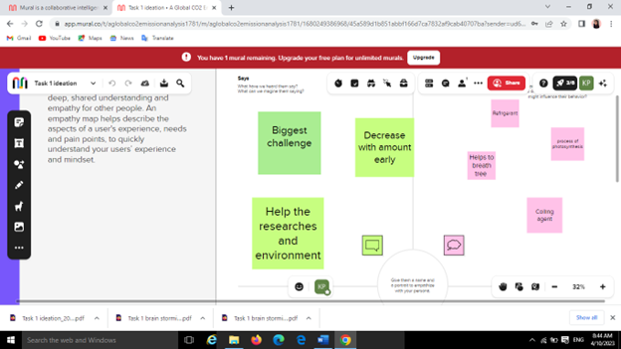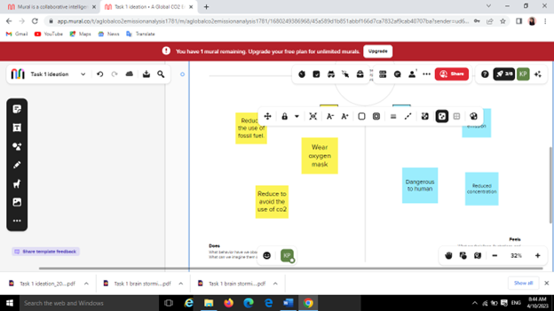

2.2 ideation & brainstorming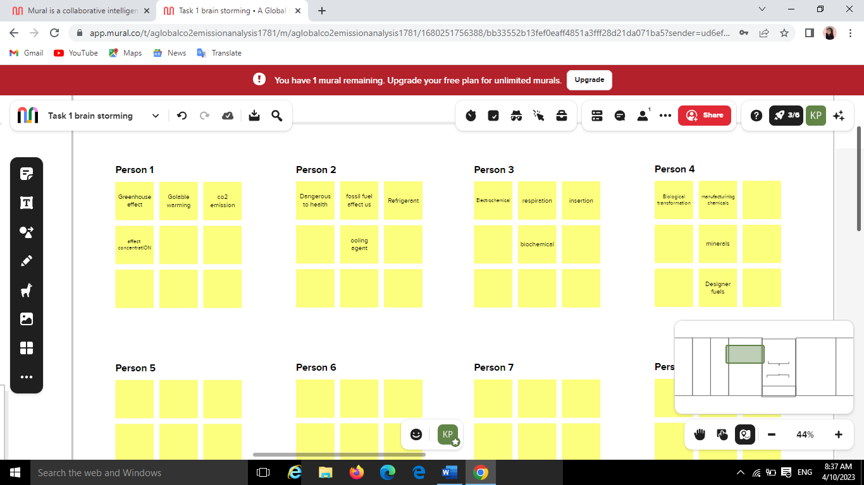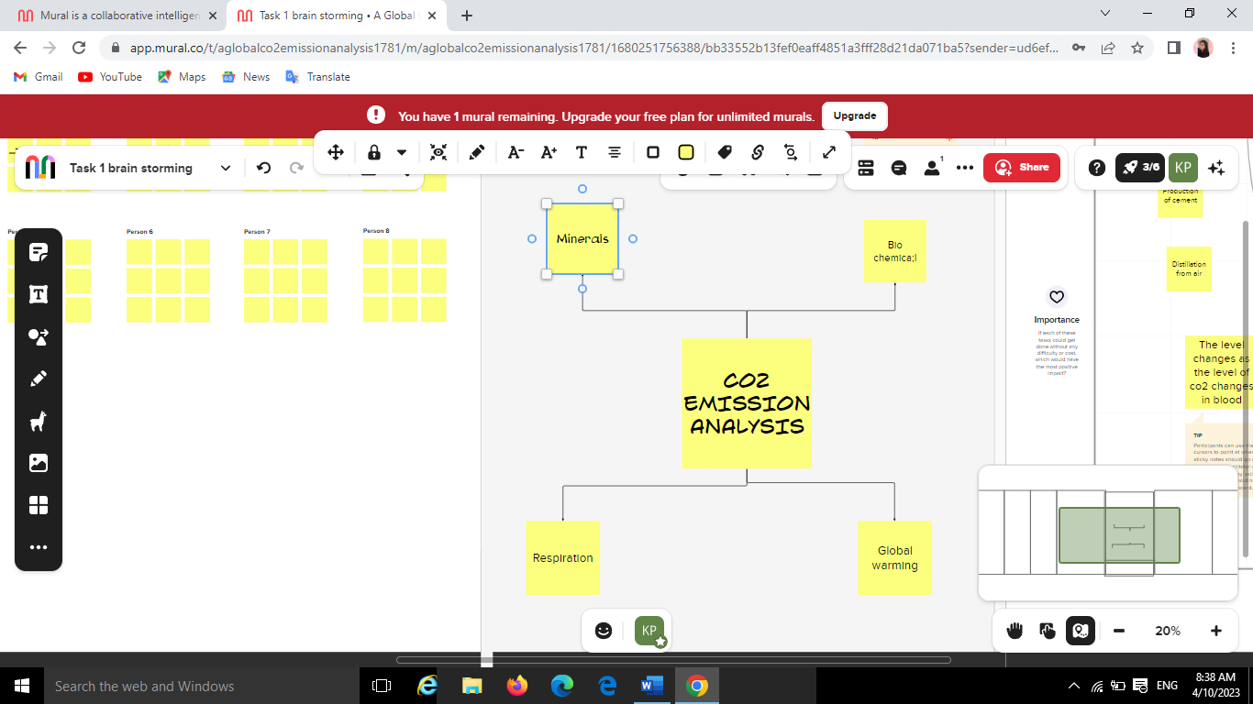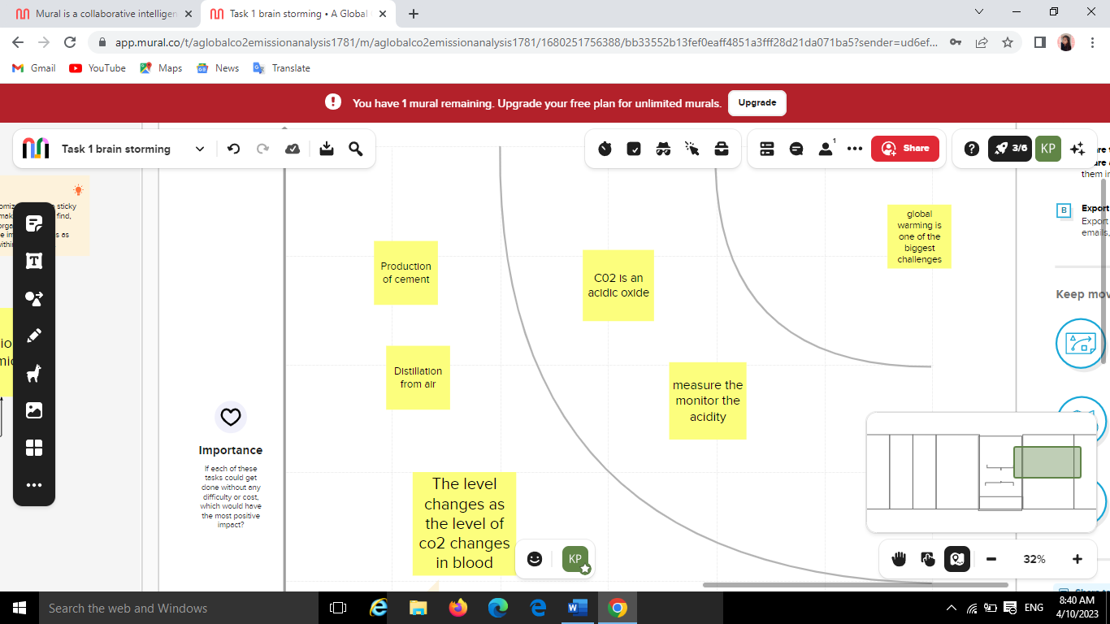

1. RESULT

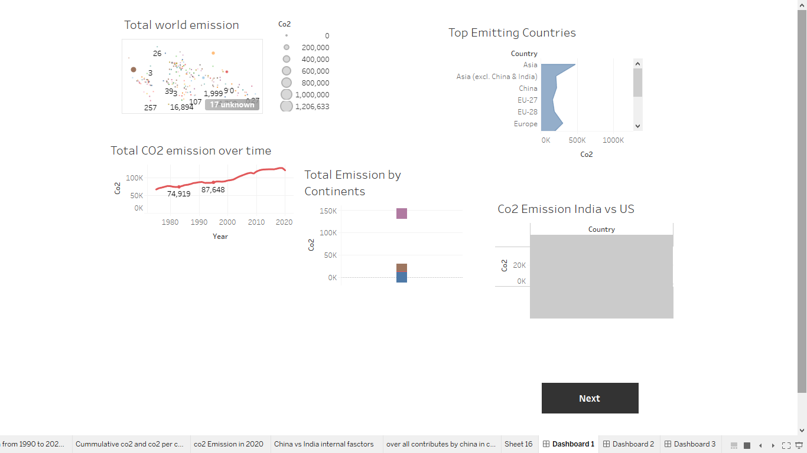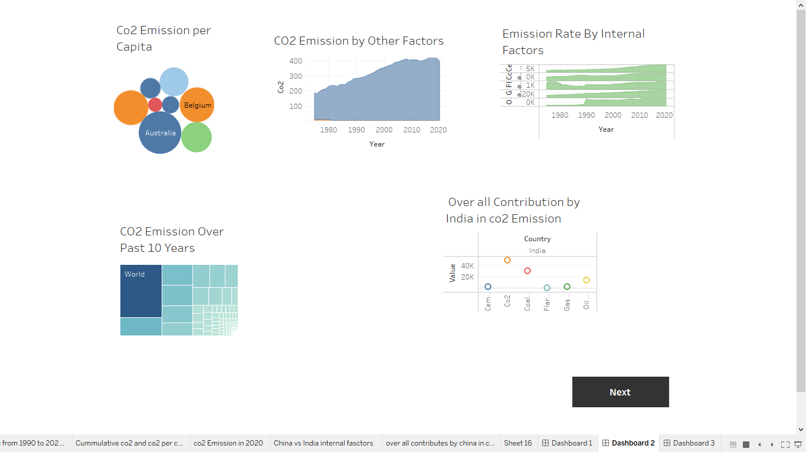

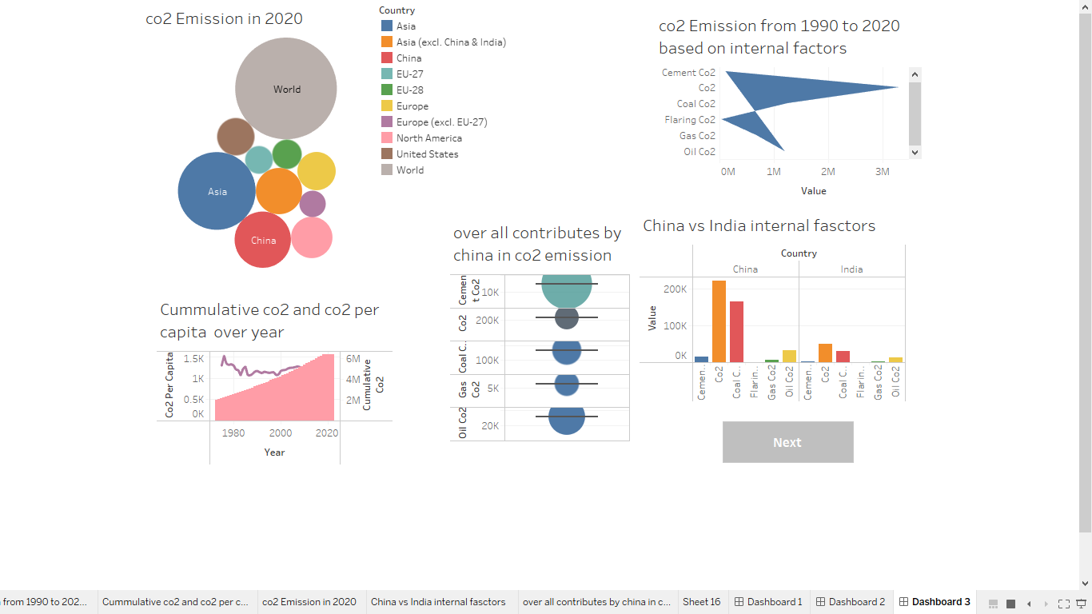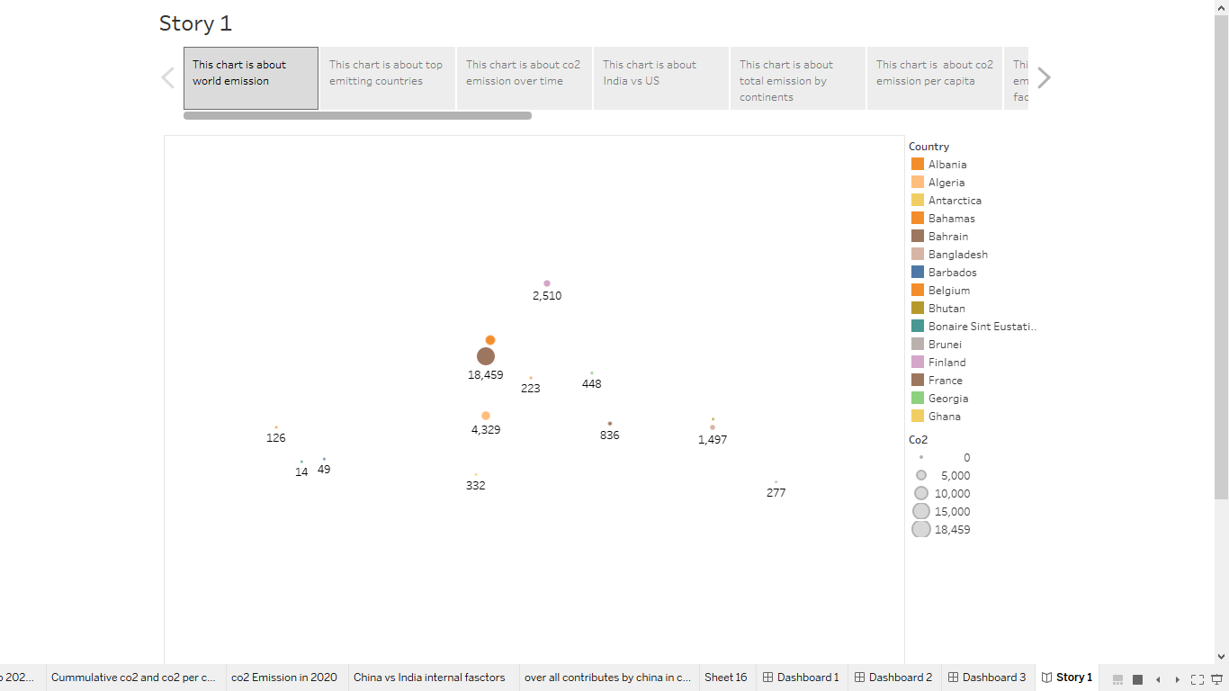

1. Advantage & disadvantage

Advantage:

* Concentrated in co2
* High pressure
* Removes the need for co2piping to transport the gas to underground storage sites.

Disadvantages:

* Direct cycles require removal of water from the fluid before recycling.
* Gas turbines running on hydrogen are a huge challenge.

1. Applications

Using various catalyst, co2 can be made into a variety of chemical intermediaries’ materials that then serve as feedstocks in other industrial processes, like

* Methanol
* Syngas and
* Formic acid.

1. Conclusion

Co2 capture and storage is technologically feasible and could play a significant role in reducing greenhouse emission over the course of this century.

1. Future Scope

The latter, which sees most emissions come from deforestation and peatland clearance, now says it will cut emissions level by at least 31.89% by 2023. Globally, inadequate pledges put the world on a path to warm by 2.5 by 21000. Still, 10.6% increase in emissions represents slight progress.

8. Appendix

A. Source code: Kavitha's Team Project.html